Laboratory Assignments Subject: Introduction to Databases

Subject code: CSE 3151

**Assignment 2: Practicing DDL and DML Commands**

# Objective of this Assignment:

* To solve simple queries using DDL and DML statements over tables based on assignment 1.

# Write the SQL Expressions for the following SQL Queries and verify it in your PC by executing it.

* 1. Display the structure of all the tables you have created in assignment (1).

EXEC sp_columns INSTRUCTOR;

EXEC sp_columns COURSE;

EXEC sp_columns DEPARTMENT;

EXEC sp_columns TEACHES;

EXEC sp_columns PREREQ;

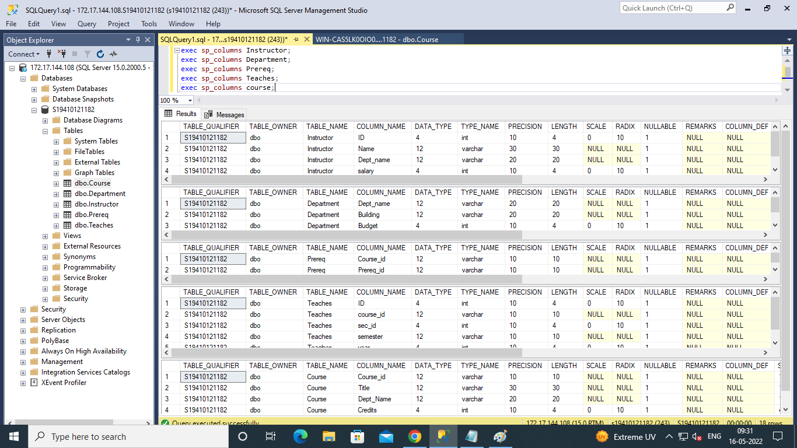

* 1. Display the contents of all the tables you have created in assignment (1).

SELECT * FROM INSTRUCTOR;

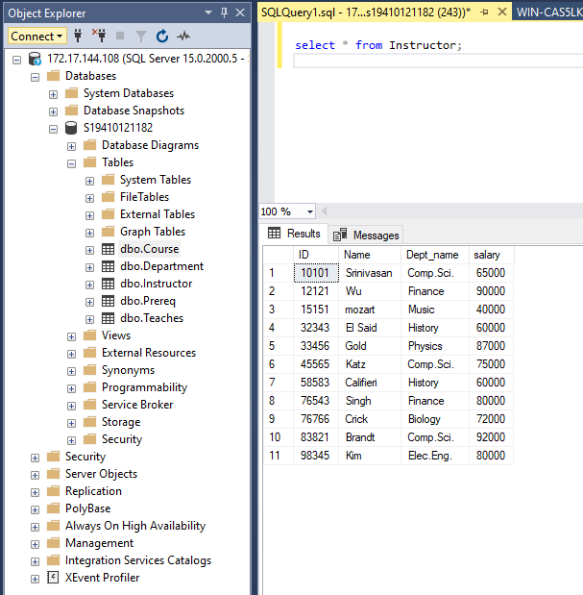

SELECT * FROM COURSE;

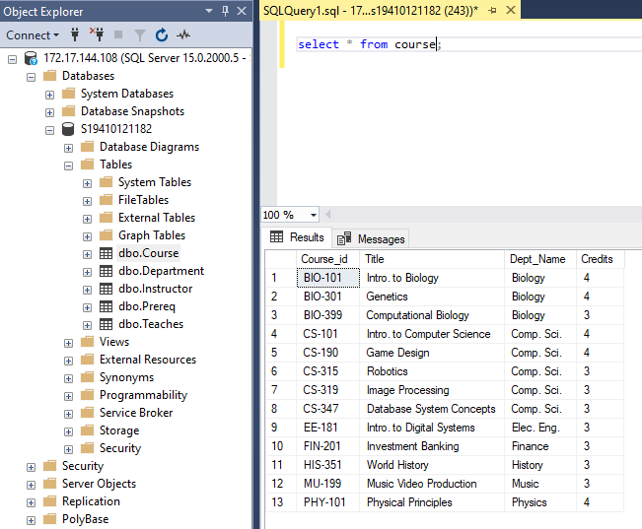

SELECT * FROM DEPARTMENT;

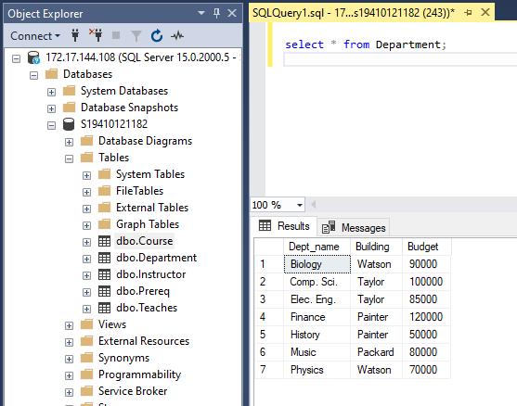

SELECT * FROM PREREQ;

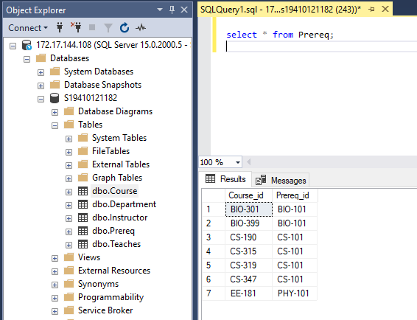

SELECT * FROM TEACHES;

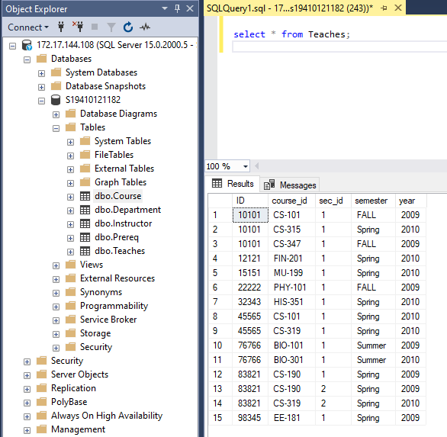

* 1. Display the name and department of each instructor.

SELECT NAME,DEPT_NAME FROM INSTRUCTOR;

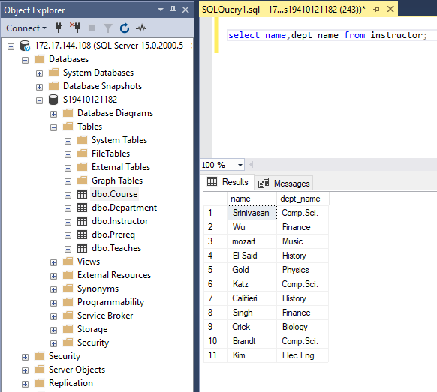

* 1. Display the name and salary of Comp. Sci. Instructors.

SELECT NAME,SALARY FROM INSTRUCTOR WHERE DEPT_NAME='COMP. SCI.';

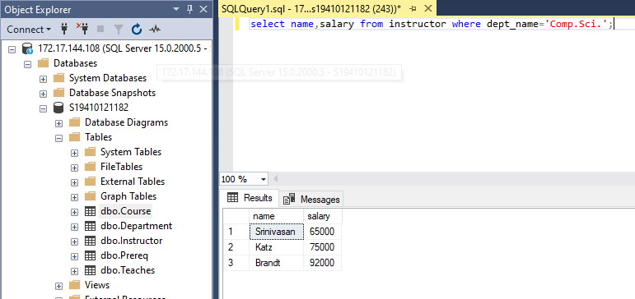

* 1. Display the records of instructor who belongs to Physics department and getting salary

less than 90000.

SELECT * FROM INSTRUCTOR WHERE DEPT_NAME='PHYSICS' AND SALARY<90000;

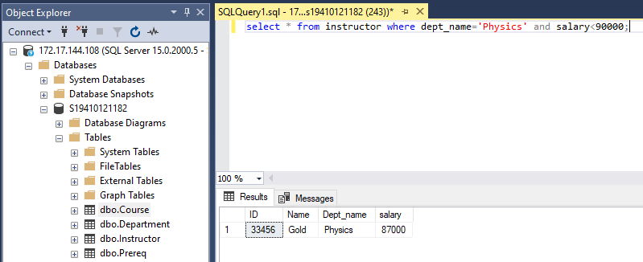

* 1. Display the name of the instructors who do not belong to Comp. Sci. Department.

SELECT NAME FROM INSTRUCTOR WHERE DEPT_NAME!='COMP. SCI.'; 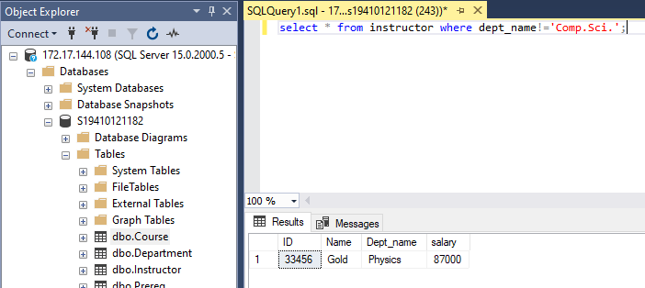

* 1. Display the names of the different department distinctly available in Instructor table.

SELECT DISTINCT DEPT_NAME FROM INSTRUCTOR;

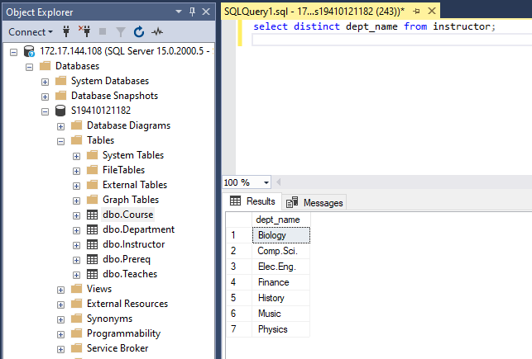

* 1. Display all Course_id‘s that are taught in Spring semester of 2009.

SELECT COURSE_ID FROM TEACHES WHERE SEMESTER='SPRING' AND YEAR=2009;

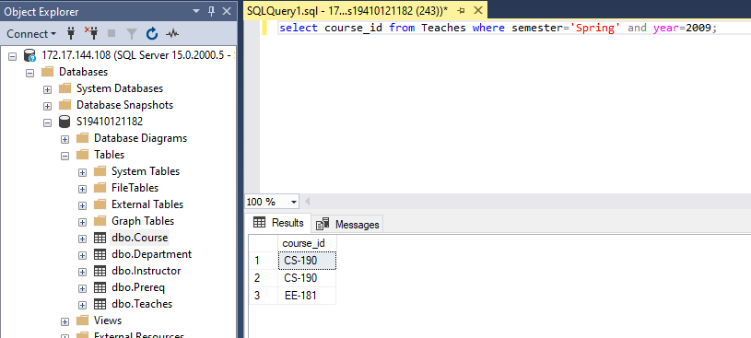

* 1. Display course titles that are taught in Comp. Sci. Department and do not have credit

equals to 3.

SELECT TITLE FROM COURSE WHERE DEPT_NAME='Comp.Sci.' AND CREDITS!=3; 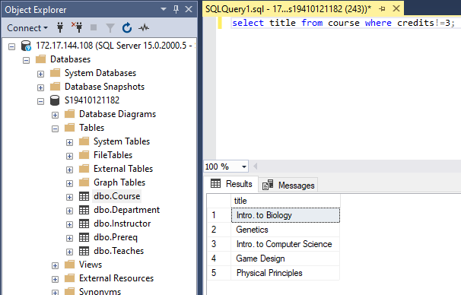

* 1. Display all columns of course table sorted in descending order of department names.

SELECT * FROM COURSE ORDER BY DEPT_NAME DESC;

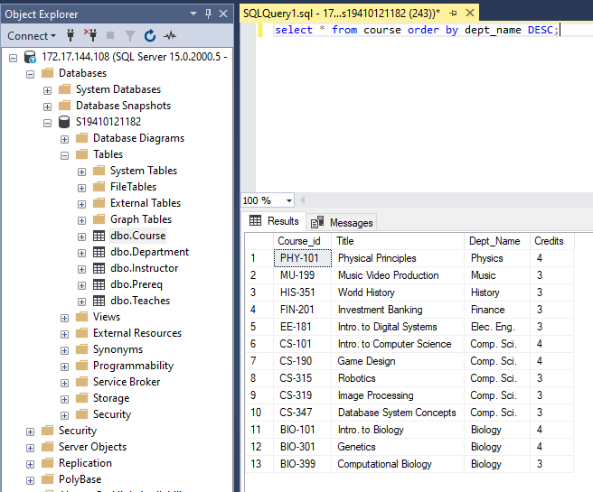

* 1. Add a date_of_join column to instructor table.

Alter table instructor add date_of_join DATE;

* 1. Insert date values to existing rows.

update Instructor set date_of_join='2022-05-16';

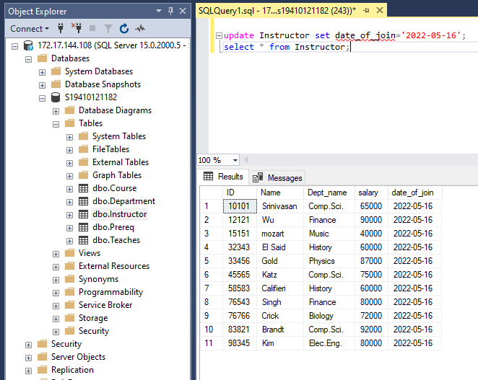

* 1. Change the name of dept_name to department in all the tables.

SP_RENAME 'DBO.INSTRUCTOR.DEPT_NAME','DEPARTMENT';

SP_RENAME 'DBO.COURSE.DEPT_NAME','DEPARTMENT';

SP_RENAME 'DBO.DEPARTMENT.DEPT_NAME','DEPARTMENT';

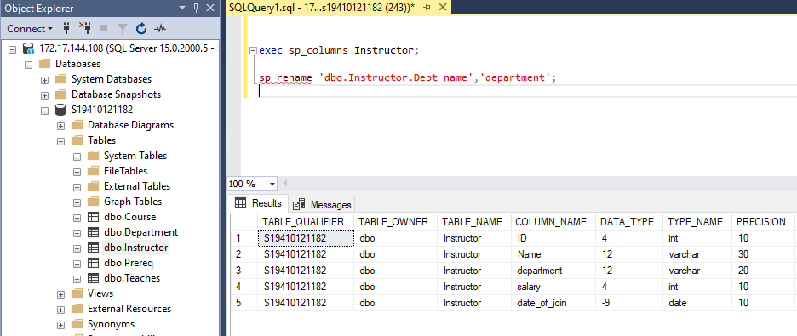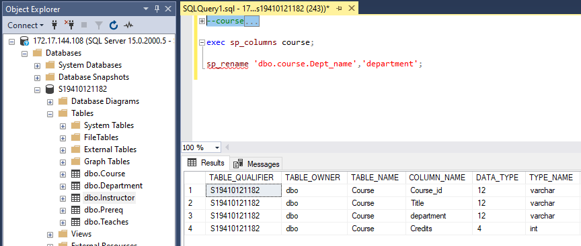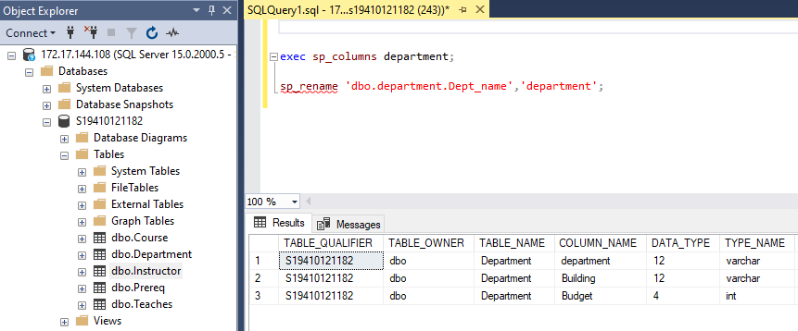

* 1. Change the name of “Prereq” table with new name “Prerequired”.

EXEC sp_rename 'DBO.PREREQ', 'PREREQUIRED';

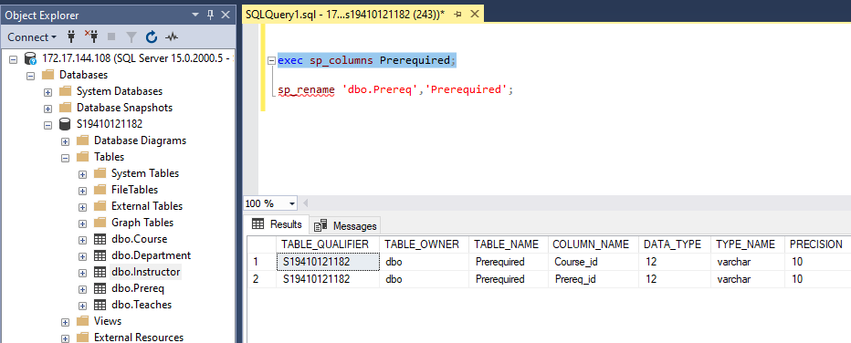

* 1. Change Course_id column name to Sub_code.

SP_RENAME 'DBO.COURSE.COURSE_ID','SUB_CODE';

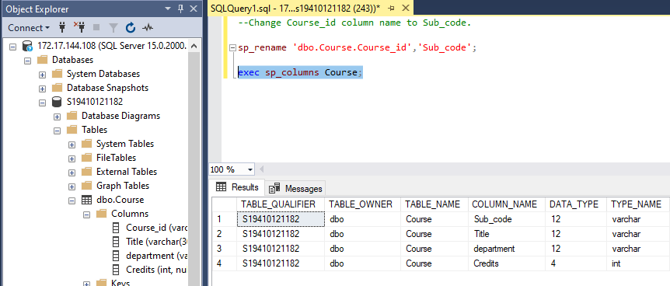

* 1. Change the data type of name to varchar2 (50).

ALTER TABLE INSTRUCTOR ALTER COLUMN NAME VARCHAR(50);

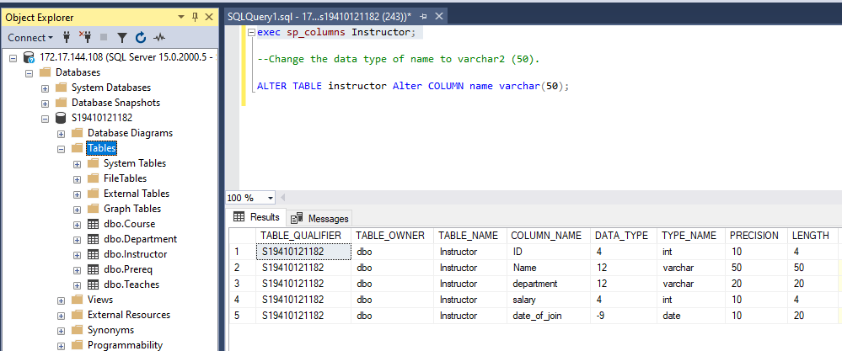

* 1. Change the name of Instructor table to Faculty_Info.

EXEC sp_rename 'DBO.INSTRUCTOR', 'FACULTY_INFO';

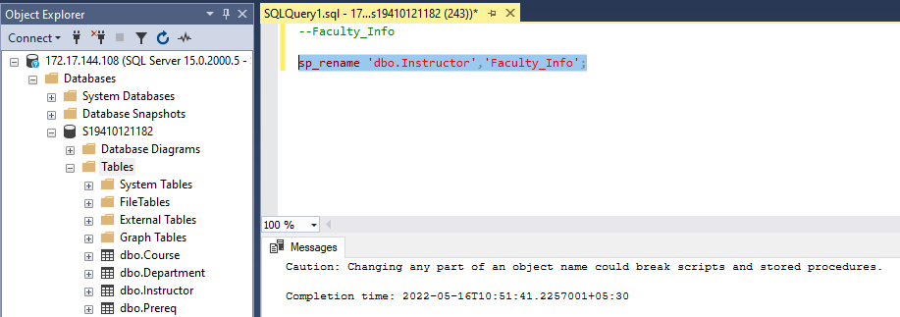

* 1. Change the Column size of Course_id in Course table from 10 to 8.

ALTER TABLE COURSE ALTER COLUMN Sub_code VARCHAR(8);

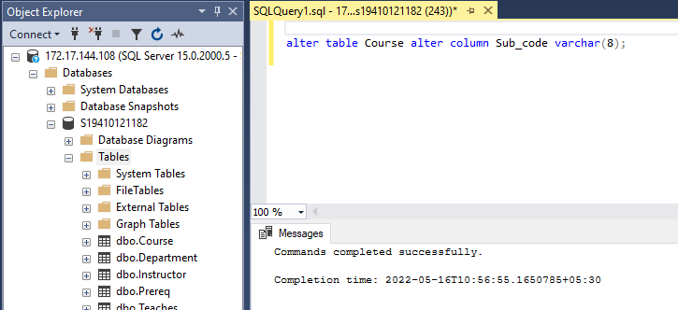

* 1. Delete the content of the table Prereq along with its description.

DELETE FROM PREREQUIRED;

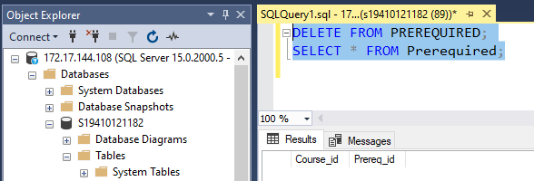

* 1. Change the column name ‘Building’ of Department table by new column name ‘Builder’.

SP_RENAME 'DBO.DEPARTMENT.BUILDING,'BUILDER';

